# TechShop System Deployment & Integration

## 1. Technology Stack

The TechShop e-commerce platform utilizes a modern technology stack for optimal performance, security, and scalability.

* • Backend: ASP.NET Core (C#) for business logic and API services.
* • Frontend: React.js or Vue.js for dynamic and responsive UI.
* • Database: SQL Server for structured and efficient data storage.
* • Hosting: Azure or AWS for cloud-based deployment and scalability.
* • Authentication: JWT-based authentication and OAuth for third-party login.
* • Payment Integration: Stripe, PayPal, and other secure gateways.

## 2. Deployment Diagram

The deployment diagram below illustrates how TechShop components are distributed across different hardware nodes.

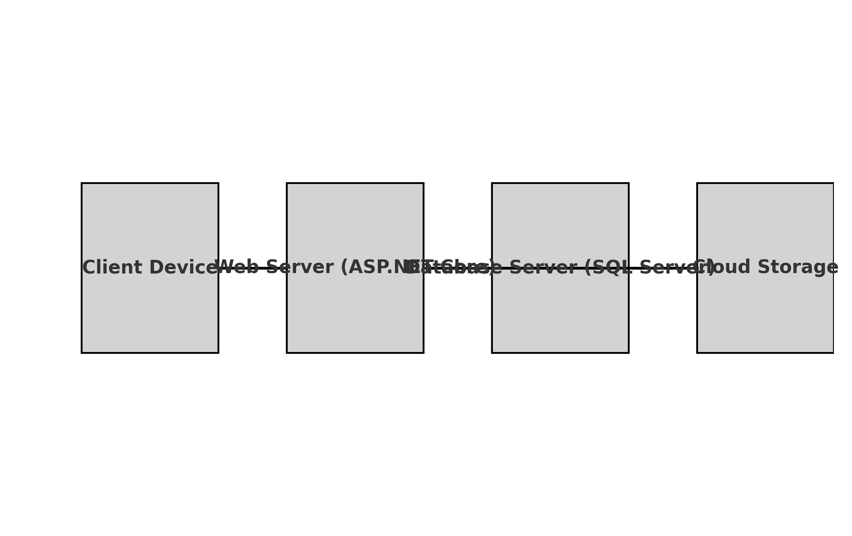

## 3. Component Diagram

The component diagram below illustrates the high-level system components and their dependencies.

